 | Bansilal Ramnath Agarwal Charitable Trust’s Vishwakarma Institute of Information Technology  Department of  Artificial Intelligence and Data Science
Student Name: Sathe Onkar Abasaheb
Class: TY | Division: B |  | Roll No: 372078
Semester: V |  | Academic Year: 2025-2026
Subject Name & Code: Cloud and DevOps
Assignment No: 04
Title of Assignment:Launch and configure an EC2 instance with a web server.

Date of Performance: / /2025 |  | Date of Submission: / /2025
Aim: To execute Linux commands (file operations, process management, user management)

Objective: To learn basic Linux commands like file operations, process management and user management

Materials Required: Laptop with Arch Linux(OS kernel Linux 6.12.45-1-lts) installed in it, zsh(highly configured .zshrc).

1. Introduction
Amazon Web Services (AWS) is a leading cloud computing platform that provides scalable and flexible infrastructure services. One of the most widely used services is Amazon Elastic Compute Cloud (EC2), which allows users to rent virtual machines (instances) to run applications, host websites, or perform computations on demand.
This assignment focuses on the procedure of launching and configuring an EC2 instance on AWS. The steps include account setup, instance creation, security configuration, connection, and basic software installation.

2. Objectives
The objectives of this assignment are:
- To understand the process of launching an EC2 instance on AWS.
- To learn how to configure networking and security groups.
- To connect to the EC2 instance using SSH.
- To install and configure basic software on the instance.

3. Procedure

Step I:
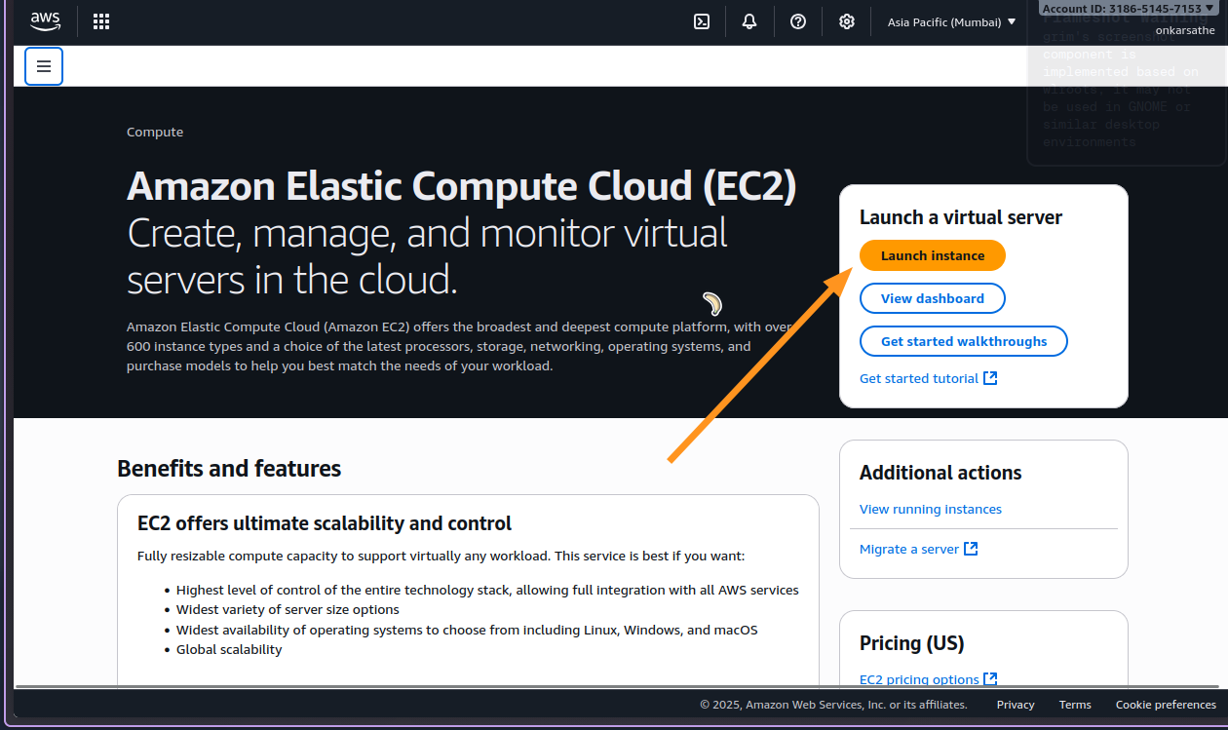
- Name & Tags
  - Enter a meaningful name (e.g., MyFirstEC2).
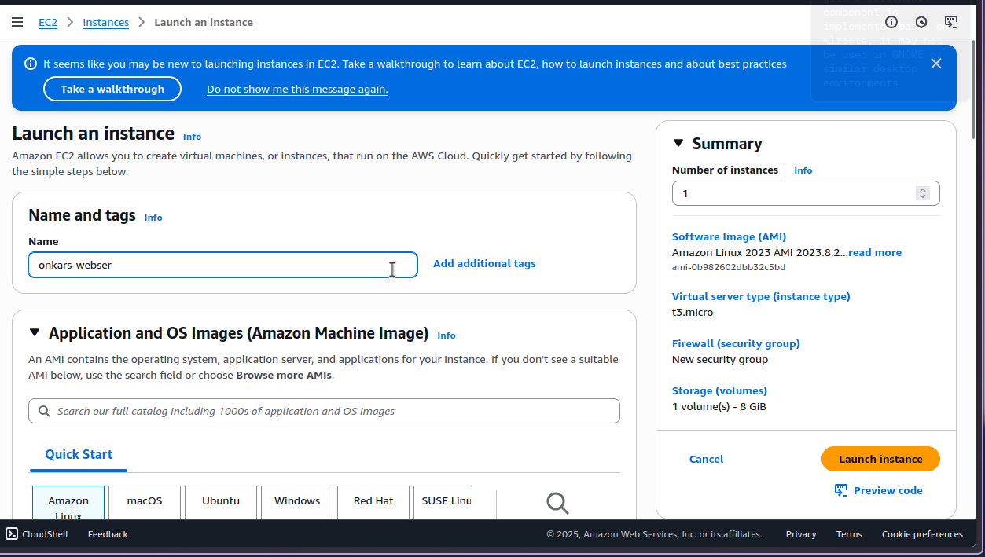

- Choose Amazon Machine Image (AMI)
  - Example: Amazon Linux 2 AMI (Free Tier eligible).
  - You can also choose Ubuntu, Windows Server, or others depending on requirements.
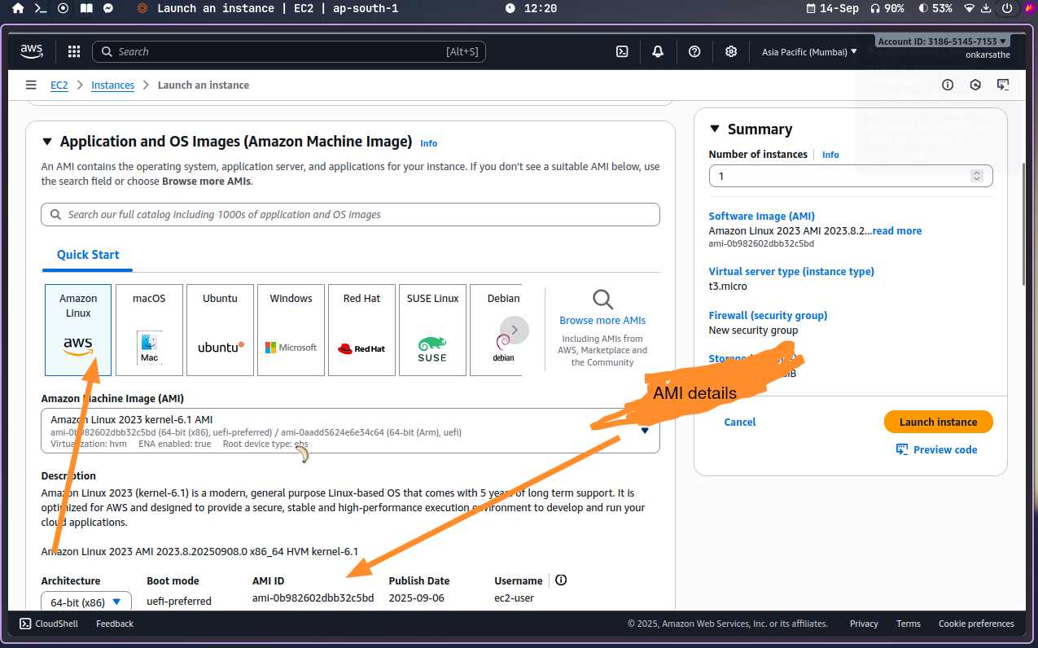
- Choose Instance Type
  - For Free Tier: Select t2.micro (1 vCPU, 1 GB RAM).
  - For higher workloads: Choose larger types like t2.medium or m5.large.
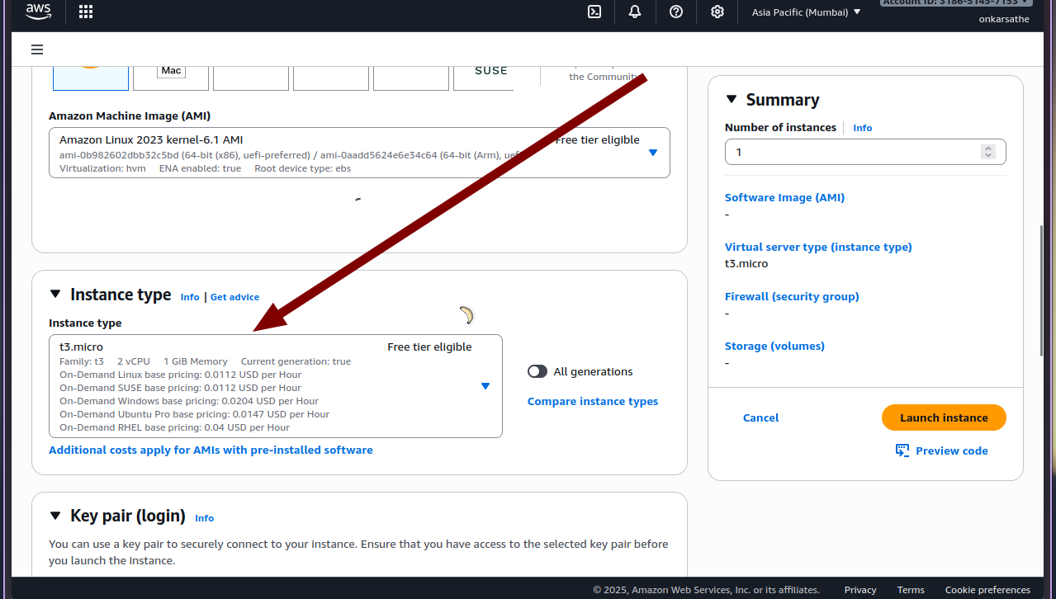
- Create Key Pair (for SSH)
  - If you don’t have a key pair, create a new one (.pem file for Linux/Mac or .ppk for Windows).
  - Download and store it securely.
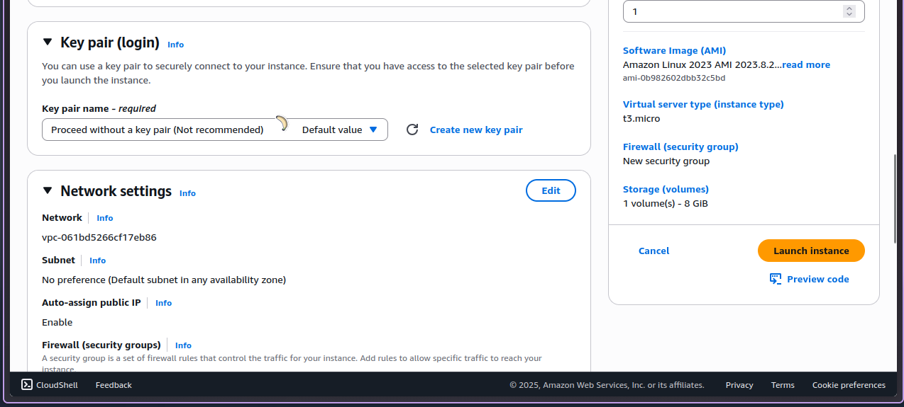
- Configure Network Settings
  - Choose default VPC or create a custom one.
  - Enable Auto-assign Public IP to access instance over the internet.
  - Add rules in Security Group:
    - SSH (port 22) → My IP
    - HTTP (port 80) → Anywhere (if hosting a web server)
    - HTTPS (port 443) → Anywhere
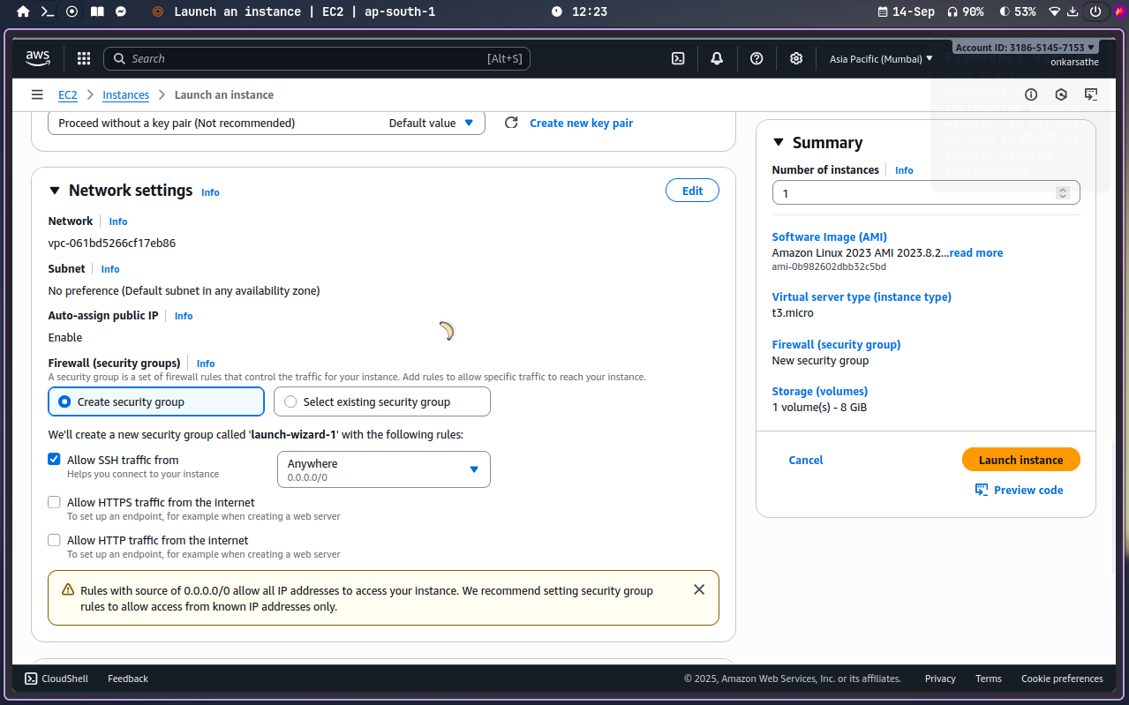
- Storage Configuration
  - Default: 8 GB General Purpose SSD (gp3).
  - You can increase if needed.
- Review and Launch
  - Check all details.
  - Click Launch Instance.
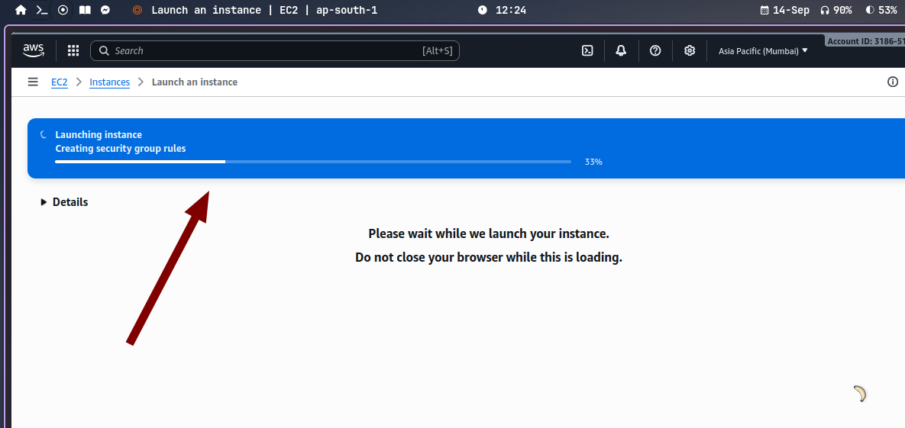

Step 4: Accessing the Instance
- After launching, go to EC2 Dashboard → Instances.
- Select your instance and copy the Public IPv4 address.
- On your tier
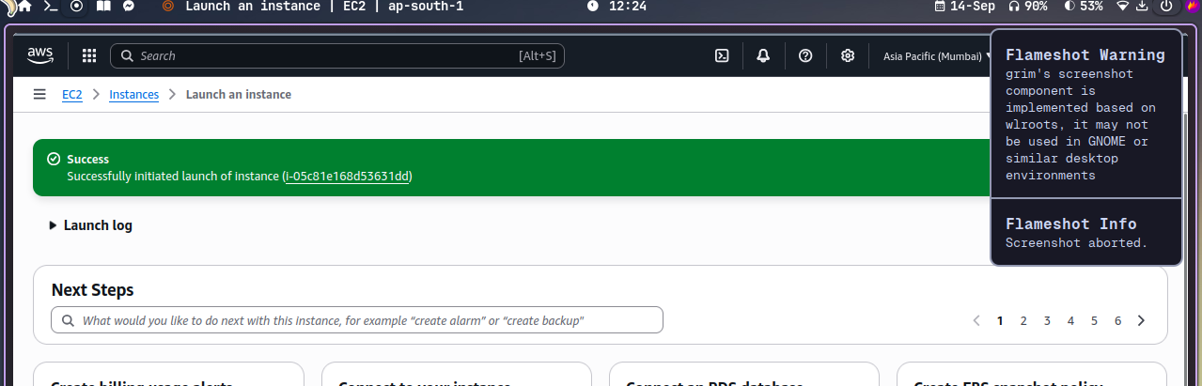
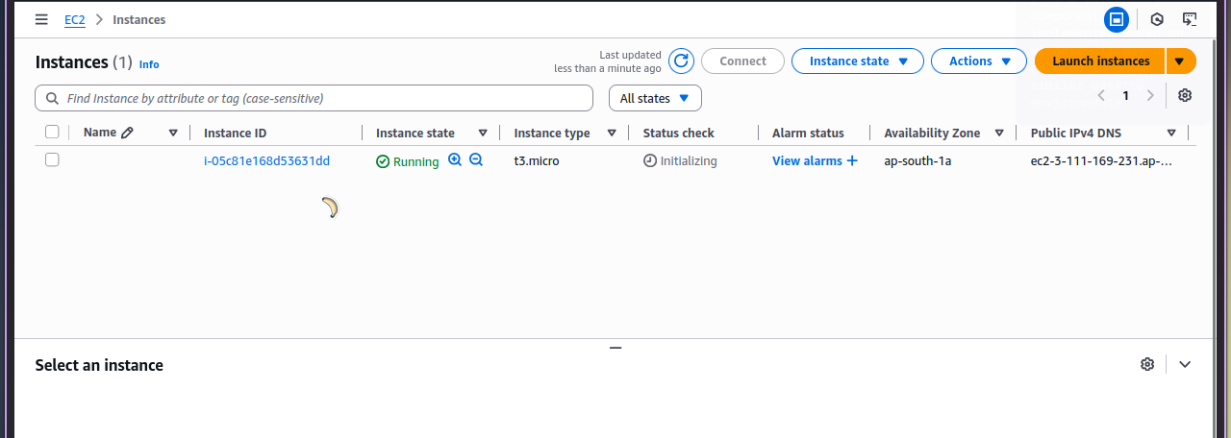
Conclusion:

This assignment demonstrated the complete process of launching and configuring an Amazon EC2 instance. Starting from account login, choosing AMI, setting security groups, connecting via SSH, and finally installing software, the exercise provided practical knowledge of AWS cloud computing. Mastery of EC2 is a foundational skill for cloud engineers, system administrators, and developers.

